**Stutter Support User Manual**

Thank you for downloading *Stutter Support*! *Stutter Support* is a mobile app designed for the HTC One M7 Android phone. The purpose of *Stutter Support* is to help you relax, and practice speaking with easy, relaxed sounds. We hope that *Stutter Support* will make practicing your speech more engaging and enjoyable.

**Table of Contents**

|  |  |
| --- | --- |
| Splash Screen | pg. 2 |
| Navigating the Menu | pg. 2 |
| Understanding the Tracker | pg. 4 |
| Changing the Settings | pg. 5 |
| Playing *No Need to Shout* | pg. 7 |
| Playing *Relax* | pg. 9 |
| Playing *Leave a Message* | pg. 10 |
| Sharing on Social Media | pg. 11 |
| Daily Notifications | pg. 12 |
| Appendix A: *No Need to Shout* vocabulary list | pg. 13 |
| Appendix B: *Leave a Message* script list | pg. 14 |
| Appendix C: Settings | pg. 15 |

**Splash Screen**

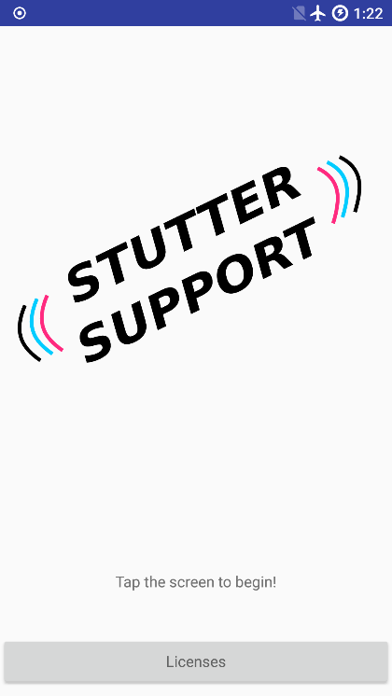

When you first open the app, you’ll see the splash screen. Tap anywhere on the screen other than the small ‘Licenses’ button at the bottom and the main menu will open. Tap the ‘Licenses’ button, and the third-party licenses will appear.

**Navigating the Menu**

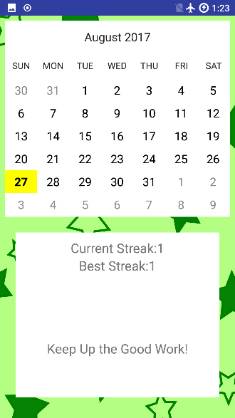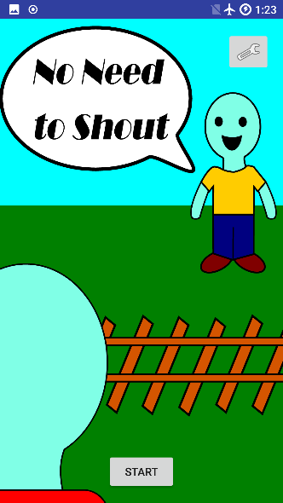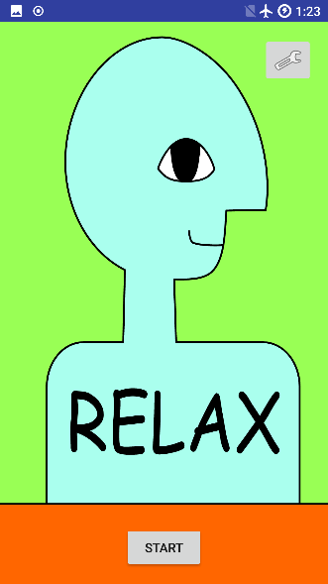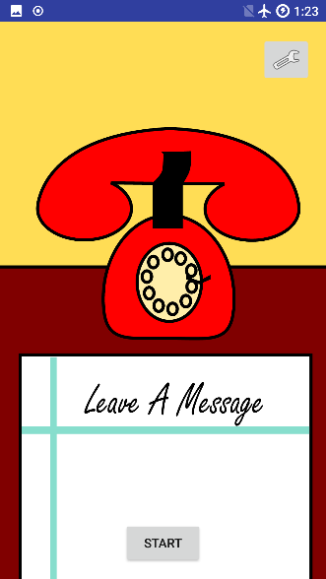

The first thing you will see on the main menu is the Tracker. This screen shows you which days you’ve used *Stutter Support*, and for how many days in a row. For more information, please see the section *Understanding the Tracker*.

Swipe left and right on the touch screen to navigate through the menu. Grey indicators appear at the side of the screen when you have reached the end of the menu and can only go back in the other direction.

Tap the ‘START’ button at the bottom of the screen to start the activity shown on screen. For more information on how to play each activity, please see the sections *Playing No Need to Shout*, *Playing Relax*, and *Playing Leave a Message*.

Tap the wrench button at the top right corner of the screen to open the settings for the activity shown on screen. For more information on changing the settings, please see the section *Changing the Settings*.

**Understanding the Tracker**

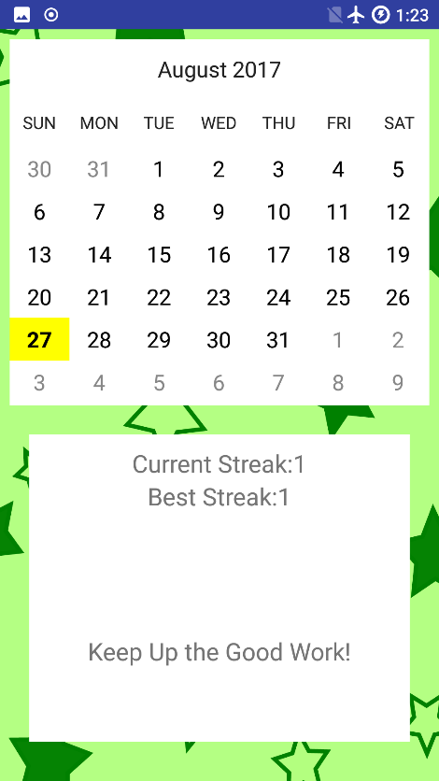

The first screen in the main menu is the Tracker, which shows you which days of the current month, and how many days in a row, you’ve successfully completed at least one activity.

On the top half of the screen is the calendar. The **bold** date indicates today’s date. The yellow highlighting indicates a day on which you’ve successfully completed at least one activity.

On the bottom half of the screen is the streak information. The *Current Streak* is how many days in a row you’ve successfully completed an activity leading up to today. The *Best Streak* is the most days in a row you’ve ever successfully completed an activity. Make practicing your speech a habit, and try to beat your best streak!

**Changing the Settings**

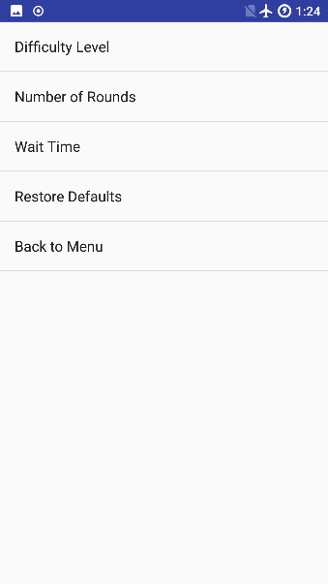

Tap the wrench button in the top right corner of the main menu to open the Settings screen for each activity. Each activity has different settings associated with it. For a full explanation of each setting for each activity, please see *Appendix C: Settings*.

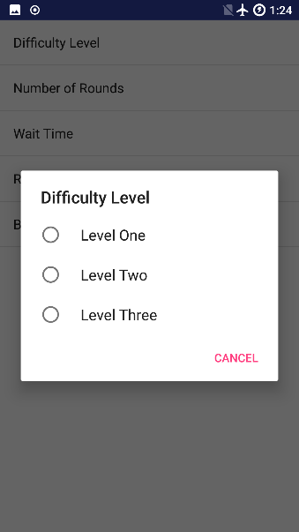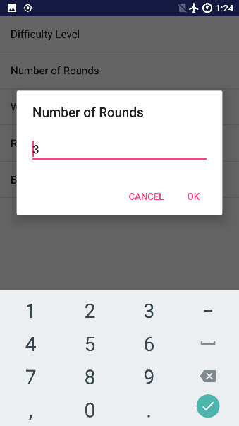

Tap the name of a setting to change it. Depending on the nature of the setting, a list or a numeric entry field will appear. Tap the entry on the list you would like to select, or tap the numeric entry pad to enter a value for the setting. Tapping a list entry, or pressing ‘OK’ on the numeric entry, saves your setting.

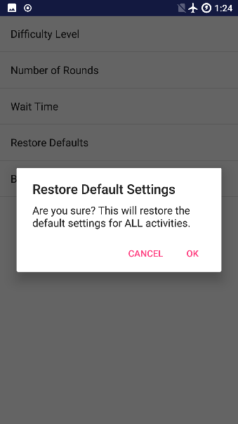

On every settings screen, there is a button to restore the default settings, and a button to return to the main menu. Tap the ‘Restore Defaults’ button to restore the default settings to the app. Tap the ‘Back to Menu’ button to return to the main menu.

**Warning:** Tapping the ‘Restore Defaults’ button will reset the settings for **all** activities, not just the one selected. A window will pop up confirming your decision.

**Playing *No Need to Shout***

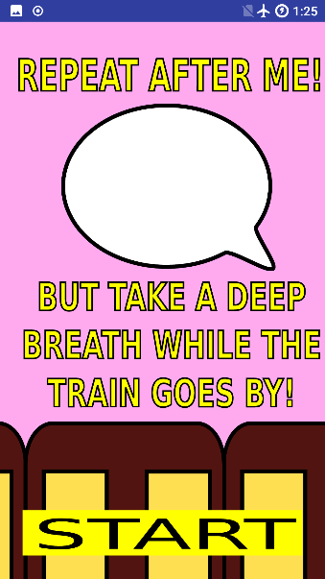

Every activity starts with an instruction card while the rest of the activity loads. When the yellow ‘START’ button appears, tap the ‘START’ button to begin the activity.

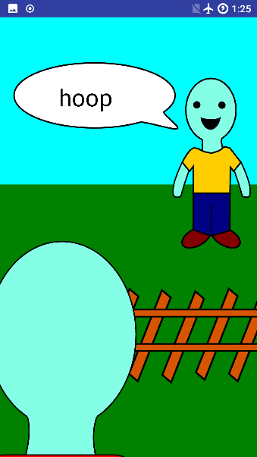

Remember what the character on the other side of the tracks said. The goal of the game is to repeat the word back to him once the train has passed by.



Take a deep breath and relax your voice muscles while the train car passes by.

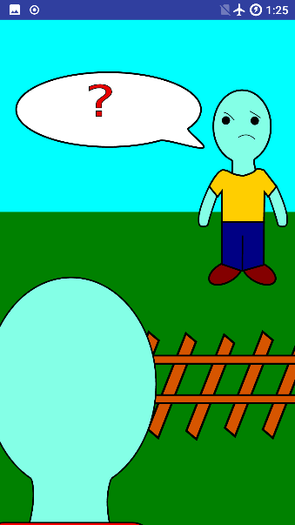

Repeat the word back to the character once the train car has passed and he is shown waiting for your response.

If you respond too early (when he is speaking or when the train car is passing by) you will see him confused by your response, and give you a new word to remember.

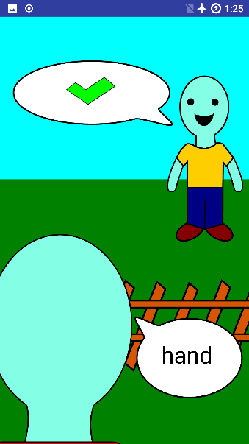

Speak the word into the phone’s microphone. Remember to use easy onset! If the character heard you correctly, a green checkmark will display.

**Playing *Relax***

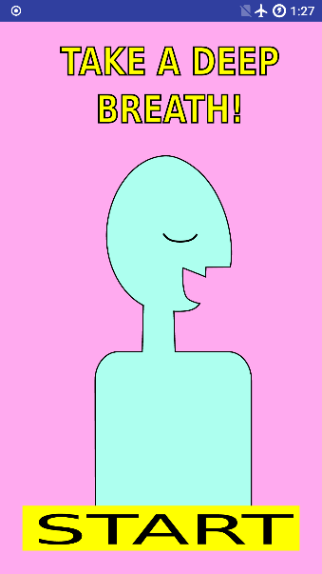

Every activity starts with an instruction card while the rest of the activity loads. Tap the yellow ‘START’ button to begin the activity.

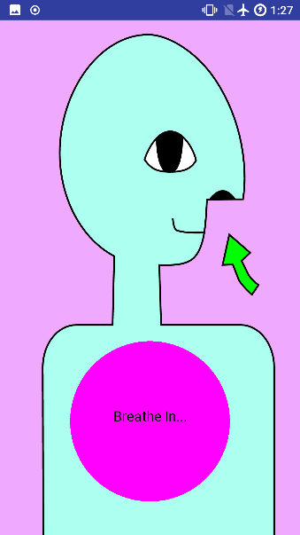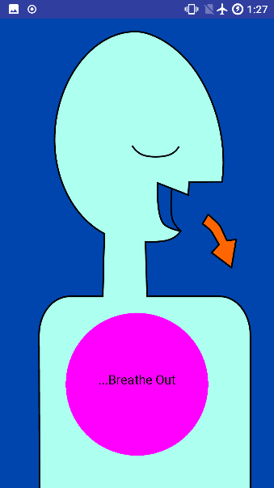

*Relax* leads you through a deep breathing exercise to help you feel calmer and relax your voice muscles. Breathe along with the animation onscreen.

**Playing *Leave a Message***

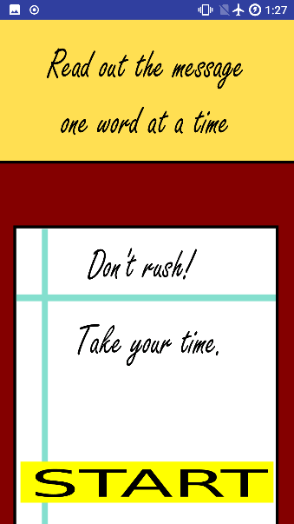

Every activity starts with an instruction card which displays while the rest of the activity loads. Tap the yellow ‘START’ button when it appears to begin the activity.

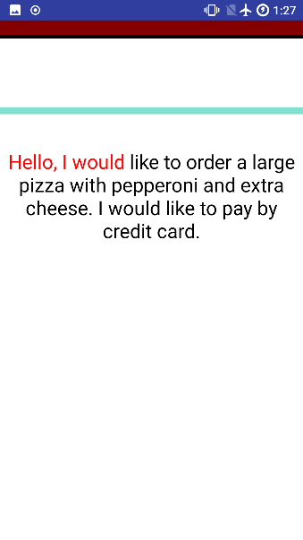

Read out each word, slowly. The purpose of *Leave a Message* is to practice common phone messages without being rushed or nervous. The words will turn red as you read them out. Read the entire message to complete the activity.

**Sharing on Social Media**

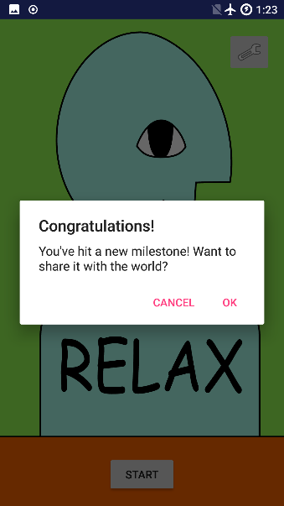

After achieving certain milestones in your streak count, the app will prompt you to share your success with other people. Tap ‘OK’ to proceed, or ‘Cancel’ to get rid of the prompt.

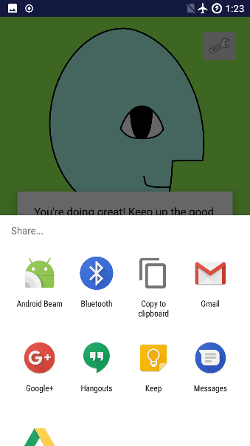

Tap the app you’d like to use to share the message. If you have social media apps installed on your phone, they will be available in this list.

**Daily Notifications**

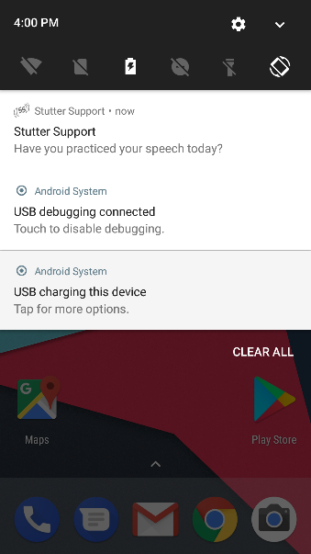

After your first use of *Stutter Support*, the app will remind you every day at 4PM to practice your speech. Tap the notification to launch *Stutter Support*, or swipe right on the notification to get rid of it.

If you’d like to disable the daily notifications, you can do so through your phone’s Settings menu.

**Appendix A: *No Need to Shout* vocabulary list**

The vocabulary of *No Need to Shout* is divided into three difficulty levels. Level One is short words starting with easy sounds (h- and vowel sounds). Level Two is slightly longer words and short words starting with some consonants. Level Three is long words and words starting with the hardest consonants (b, g, p, and k). You should pick the difficulty level that best matches what you need to practice.

*Level One*

|  |  |  |  |  |  |  |
| --- | --- | --- | --- | --- | --- | --- |
| age | aim | all | am | an | as | ash |
| edge | eight | hall | ham | hand | hard | hat |
| have | head | health | heart | height | help | high |
| hike | hill | hint | hire | hive | hog | hold |
| home | hook | hoop | hop | hope | horse | house |
| how | hug | hurt | I | oats | off | oil |
| on | oops | ounce | out | own | up | us |
| was | whole |  |  |  |  |  |

*Level Two*

|  |  |  |  |  |  |  |
| --- | --- | --- | --- | --- | --- | --- |
| above | ahead | anchor | angel | angle | answer | aware |
| awesome | awful | easy | echo | edit | effect | eject |
| elbow | empty | even | every | eyeball | fake | fat |
| fear | feel | feet | fell | felt | fight | fin |
| fire | gnat | hammer | hamster | handle | harmful | healthy |
| helmet | hornet | ignore | inquire | inside | instant | kneel |
| lake | lap | late | laugh | lay | leak | leap |
| less | let | lick | lid | lie | lies | light |
| like | lime | lip | live | loose | lose | made |
| make | map | mat | may | meal | mean | meet |
| melt | mess | met | mice | miss | moose | my |
| name | near | neat | neck | net | nice | night |
| object | ocean | office | orange | outside | oval | owner |
| rack | rag | rake | ram | rat | ray | red |
| rest | rhyme | rice | right | rip | ripe | rise |
| root | sack | said | same | sat | say | seal |
| seat | seek | seem | seen | sell | set | shake |
| sick | sight | sip | sit | size | smell | stay |
| stayed | steal | stews | still | stream | undo | wag |
| wait | wake | way | weak | well | wet | whose |
| win | wise | wreck | yes | yet | zip |  |

*Level Three*

|  |  |  |  |  |  |  |
| --- | --- | --- | --- | --- | --- | --- |
| alligator | back | bag | bake | bat | bay | beak |
| bean | beat | bed | beep | bell | belt | best |
| bet | bib | big | bike | bit | bite | blame |
| bless | boot | bought | bow | box | boy | braid |
| break | broke | brow | bug | bus | bye | cake |
| cat | date | day | deal | debt | deck | deep |
| deer | did | dig | dime | dive | dock | does |
| dog | done | dove | dream | duck | dug | elastic |
| errand | escape | every | example | game | gas | gate |
| gear | geese | gem | get | give | globe | glove |
| go | goat | gone | goose | grass | gray | greet |
| grill | grin | guess | guest | gum | illustrate | incredible |
| keep | kick | kid | kiss | kite | outstanding | pack |
| pass | pat | pay | peace | peak | peel | pest |
| pet | pick | pie | pig | pill | pin | poem |
| poke | pool | pot | tag | take | talk | tall |
| tame | tap | team | tell | tie | tight | time |
| tip | toad | toe | tool | top | toss | tough |
| toy | treat | tub | tug | understand |  |  |

**Appendix B: *Leave a Message* script list**

The scripts in *Leave a Message* have been designed to emulate common scenarios in which you’d need to talk to someone on the phone.

* Hello, I would like to order a large pizza with pepperoni and extra cheese. I would like to pay by credit card.
* Hello, I would like to book an appointment to see a doctor. I have a very bad cold.
* Hello, I am calling because I would like a different time for my dentist appointment. Please let me know if Monday afternoon would be okay.
* Hello Grandma, I got your message. I would love to see you on Saturday afternoon. See you then.

**Appendix C: Settings**

*No Need to Shout*

|  |  |
| --- | --- |
| Difficulty Level | Determines the vocabulary used within the game. For a complete list of the vocabulary used in each level, please see *Appendix A:* No Need to Shout *vocabulary*. |
| Number of Rounds | How many words you must repeat back to complete the game. |
| Wait Time | How long you must wait before repeating back the word. |
| Restore Defaults | Restores default settings to all activities. |
| Back to Menu | Returns you to the main menu. |

*Relax*

|  |  |
| --- | --- |
| Inhale Length | How long to breathe in. |
| Exhale Length | How long to breathe out. |
| Number of Breaths | How many breaths should be done before the activity is considered complete. |
| Restore Defaults | Restores default settings to all activities. |
| Back to Menu | Returns you to the main menu. |

*Leave a Message*

|  |  |
| --- | --- |
| Restore Defaults | Restores default settings to all activities. |
| Back to Menu | Returns you to the main menu. |